**Order Information:** Abdominal MRI examination without contrast (ICD9-74181). Cardiac MRI examination without contrast (ICD9-75557)

**Sedation:** To be evaluated on a case-by-case basis by the radiology/anesthesiology staff responsible for this care.

**Exam Duration**: This will vary from 20” to 60” depending on local expertise and imaging protocols.

**Patient Position:** Supine, either head or feet first. If the sites are using the Ferriscan technique for liver iron quantification, a saline bag should be positioned on the patient's right hand side as to be located in the transverse imaging plane as the liver.

**Imaging Coil**: Phased array torso or cardiac coil, according to patient habitus. Imaging field of view for the abdomen will span from the dome of the diaphragm to the inferior poles of the kidneys. Imaging field of view for the heart will span from the mid-sternum to 10 cm below the nipple line.

**Gating/Triggering:** Cardiac gating is necessary. ECG gating is preferred, however peripheral pulse or pulse oximeter triggering is acceptable. Respiratory bellows monitoring (or its equivalent) should be used to assess cooperation with breath-holding.

**Breath-holding:** The Ferriscan analysis can only be performed with patients freely breathing. The cardiac T2* and liver R2* images should be collected using breath-hold imaging whenever possible. However, some patients will not be capable of breath-holding. All R2* image parameters will remain the same in free-breathing or breath-held studies except that the number of signal averages will be increased from one to three for free-breathing patients (but never for the Ferriscan sequences). Respiratory triggering for R2* is not supported on all platforms and should not be used.

**Setting up a Scanning Protocol:** It will be important to set up and test a scan protocol prior to initiating patient studies. This will provide a consistent naming convention and parameter values for cardiac and heart iron imaging sequences. Some sites have well established protocols for measuring heart and liver iron in their patients; these sites can use their standard techniques for patients participating in this clinical trial. However, some sites will not have experience in iron quantification by MRI. This document provides some guiding principles to improve image comparability across sites.

**Scanning the Ferriscan Test Object:** Some sites may use the Ferriscan technique for liver and heart iron assessment. If so, Resonance Health (the company that provides the Ferriscan analysis) requires these sites to scan a test object or "phantom" prior to conducting patient studies. Details for object positioning and scanning are provided by Resonance Health. This object is not well suited for analyzing T2* values because the vials are surrounded by air and prone to susceptibility artifact.

# Recommendations on MRI acquisition

Cardiac T2* imaging: Following patient positioning and verification of acceptable cardiac and respiratory gating, the exam will typically start with initial 3-plane localizers (axial, sagittal, and coronal), followed by a reference scan to enable accelerated cardiac imaging.

Cardiac localizing images will be collected in 3 planes: Cardiac long axis, 4 chamber and short axis views. These will be obtained according to local practice (if the institution has cardiac experience) or according to protocol described below.

1. From an axial localizer, a cine steady state free precession image (SSFP, TruFiSP, or Fiesta) image will be collected in a pseudo long axis by connecting a line from the middle of the mitral valve to the tip of the heart (Panel A of Figure 1).
2. From the pseudo long axis (Panel B), a “pre- 4 chamber” SSFP cine can be collected by drawing a line from the middle of the mitral valve to the cardiac apex as shown.
3. From the pre- 4 chamber view (Panel C), a single short axis slice can be drawn through the inflow of the ventricles to profile the mitral and tricuspid valves.
4. A true 4-chamber can be formed by placing a slice passing through the center of the mitral and tricuspid valves (Figure 2).

|  |  |
| --- | --- |
| Locizer1 | Figure 1  A) Axial localizer,  B) pseudo long axis view,  C) pre 4 chamber view |
| Fig1b | Figure 2  (Left) Cross-sectional view of the AV valves. Green line represents position of true 4 Chamber view. (Right) Resulting true 4 Chamber view. |

On the 4 chamber localizer, cardiac T2* should be collected in at least one short axis plane, passing through the middle of the papillary muscles as shown (Figure 3). The short axis slice should be positioned perpendicular to the major axis of the heart in both the long axis and four chamber views. It is good clinical practice to collect adjacent slices above and below this location because breath-hold position can vary significantly and you want the radiologist to have at least one or two heart T2* acquisitions in good position. Suggested imaging parameters for the 3 major vendors are shown in Table 1 .

|  |  |
| --- | --- |
| Localizer2 | Figure 3  Ideal position of T2* acquisition in long axis and 4 chamber views. |

# Table 1: Cardiac T2* Sequence Parameters

|  |  |  |  |
| --- | --- | --- | --- |
|  | Philips | Siemens | General Electric |
| Pulse Sequence | mTFE | Thalassemia Heart | MFGRE |
| Imaging Coil | Phased array torso | Phased array torso | Phased array torso |
| Slice Thickness | 8-10 mm | 8-10 mm | 8-10 mm |
| #Slices / #Slices per BH | 1-3 / 1 | 1-3 / 1 | 1-3 / 1 |
| Bandwidth | Min water-fat shift | Maximum | Maximum |
| BlackBlood | No | No | No |
| Flyback | No | Yes | No |
| Flip Angle | 20° | 20° | 20° |
| Repetition Time | 20-25 ms | 100 ms | 20-25 ms |
| First Echo | 1-2 | 1-2 | 1-2 |
| Echo spacing | 1-2 ms | 2 ms | 1-2 ms |
| # Echos | 8-16 | 8 | 8-16 |
| Final Echo Time | 16-18 ms | 16-18 ms | 16-18 ms |
| Field of View (F x Ph) | 32-36 x 24-27 cm | 32-36 x 24-27 cm | 32-36 x 24-27 cm |
| Frequency Matrix | 192-256 | 192-256 | 192-256 |
| Phase Matrix | 192-256 | 192-256 | 192-256 |
| #Acquisitions (NEX on GE) | 1 - Breathheld  3 - Free breathing | 1 - Breathheld  3 - Free breathing | 1 - Breathheld  3 - Free breathing |
| Options |  |  | EDR |

**Liver iron imaging:** Following patient positioning and verification of acceptable respiratory signal, the exam will typically start with initial 3-plane localizers (axial, sagittal, and coronal), followed by a reference scan to enable accelerated imaging.

**Ferriscan R2 image acquisition**: If a site choose to use the Ferriscan R2 protocol, detailed information should be obtained directly from Resonance Health (<http://www.resonancehealth.com/information-for-radiology-centres.html>).

**Liver T2*/R2* imaging:** T2* and R2* imaging are equivalent; T2* and R2* values can be interchanged using the following relationships:

T2* = 1000/R2* and R2* = 1000/T2*

**Imaging Parameters for Liver R2* Acquisition:** The same pulse fundamental sequence is used for heart and liver T2* imaging. Imaging parameters for the liver R2* assessment are slightly different than for heart and summarized in Table 2.

# Table 2: Typical Imaging Parameters for the three major MRI vendors

|  |  |  |  |
| --- | --- | --- | --- |
|  | Philips | Siemens | General Electric |
| Pulse Sequence | mTFE | Thalassemia Liver | MFGRE |
| Imaging Coils | Phased array torso  & body coil | Phased array torso & body coil | Phased array torso & body coil |
| Slice Thickness | 10 mm | 10 mm | 10 mm |
| #Slices / #Slices per BH | 1-3 / 1-3 | 1-3 / 1-3 | 1-3 / 1-3 |
| Bandwidth | Min water-fat shift | Maximum | Maximum |
| Flyback | No | No | No |
| Flip Angle | 20° | 20° | 20° |
| Repetition Time | 50-100 ms | 50-100 ms | 50-100 ms |
| First Echo | Min (must be < 1.4) | Min (must be < 1.4) | Min (must be < 1.4) |
| Echo spacing | Min | Min | min |
| # Echoes | 12 to 16 | 12 | 12 to 16 |
| Final Echo Time | 7-14 ms | 7-14 ms | 7-14 ms |
| Field of View (F x Ph) | 32-40 x 24-30 cm | 32-40 x 24-30 cm | 32-40 x 24-40 cm |
| Frequency Matrix | 64-128 | 64-128 | 64-128 |
| Phase Matrix | 64-96 | 64-96 | 64-96 |
| #Acquisitions (NEX on GE) | 1 - Breathheld  3 - Free breathing | 1 - Breathheld  3 - Free breathing | 1 - Breathheld  3 - Free breathing |
| Fat Saturation | No | No | No |
| Options |  |  | EDR |

|  |  |
| --- | --- |
|  | Figure 4  Positioning of liver slices. The highest slice should be below the costophrenic angle by at least a centimeter to minimize susceptibility artifact. |

The acquisition should consist of 1-3 contiguous slices, collected in a single breathhold, centered in the middle of the liver (Figure 4). Imaging voxels are intentionally large to improve signal to noise ratio and to decrease minimum echo time. Voxels should be 4-5 mm inplane and 10 mm through plane (slice thickness). Field of view (FOV) should be adjusted to body habitus but not decreased below 32 cm because small FOV's may prolong echo times. Repetition time and flip angle should be 50-100 ms and 20 degrees, respectively. Echo times will vary depending on the imaging parameters but the following principles should be obeyed.

#1) Shortest possible first echo at all times. To accomplish this, keep the voxel resolution in the frequency direction low (64-128). Receiver bandwidth should be as high as possible and maximum gradient strength and slew rates should be utilized (in compliance with local regulations). The target is for a minimum echo time near 1 ms. It is also critical to read every echo, not every other echo, during readout. On Philips and Siemens, this is done by disabling the “flyback” option and on General Electric this is controlled by CV18 on the user CV page.

#2) Interecho spacing should also be as short as possible. The number of echoes can be then be adjusted such that the final echo is between 7 and 14 ms. If the liver is lightly iron loaded, and one cannot collect more than 8 echoes, it is advisable to adjust the interecho spacing such that the final extends to around 14 ms.

**It is critical to understand that the echo spacing determines the dynamic range of liver iron than can be measured. Table 1 demonstrates the approximate maximum LIC that can be estimated for a given minimum echo time and echo spacing. Patients with LIC values greater than this threshold will have livers that appear exceedingly darker on the first echo time. Any patient with a liver-skeletal muscle signal ratio < 0.5 on the first echo time should be considered at risk for LIC underestimation.**

|  |  |
| --- | --- |
| 1st Echo Time | Maximum LIC |
| 0.6 | 64 |
| 0.7 | 55 |
| 0.8 | 48 |
| 0.9 | 42 |
| 1.0 | 38 |
| 1.1 | 35 |
| 1.2 | 32 |
| 1.3 | 29 |
| 1.4 | 27 |
| 1.5 | 25 |
| 1.6 | 24 |
| 1.8 | 21 |
| 2.0 | 19 |

# Recommendations on MRI Analysis

**Image Analysis:** Images should be analyzed for calculation of T2* or R2* using a validated software tool according to local clinical practice. There are two fundamentally different approaches to image quantification. Either technique is acceptable, but all patients at a given site should be processed using the same method. Below are suggested techniques to improve standardization across sites.

|  |  |
| --- | --- |
| *Screen shot 2016-01-10 at 3* | Figure 5  Example analysis using CMR Tools. A ~1 - 2cm thick region of interest is drawn in the liver periphery, excluding the liver capsule and significant vasculature. This region is further subdivided into 5 equalized size regions. Signal decay curves from each one are examined, with later echoes sequentially discarded to obtain the best fit of the initial, rapid, signal decay. The median T2* value is reported. |

*Region of Interest (ROI) Approach with Truncated Exponential:* This is the most widely implemented technique for iron quantification and is supported by software tools from CMR Tools, Circle 42, Medis, and General Electric. The user draws a ROI within the liver parenchyma, excluding major hilar vessels. We recommend a minimum of five regions, distributed near the liver periphery but excluding the liver capsule (Figure 5, bottom left figure). The software displays a signal decay curve and the user rejects later echo times that are systematically above the curve (Figure 5, bottom right). The median T2* (or R2* value) of the five regions should be used for iron calculation.

The relationship between T2* and liver iron concentration for truncated exponential analyses was described by Garbowski, et al1, and is as follows:

LIC = 31.9/(T2*)-1.014  or LIC = 0.029(R2*)1.014 (Equation 1)

where LIC is the liver iron concentration, 31.9 is constant, and T2* is raised to the negative 1.014 power. Units are in mg/g dry weight.

It is possible to perform truncated exponential fitting using free online software tools that may be found at <http://www.isodense.com/ic> 2,3. Figure 6 illustrates the use of the tools for a patient with medium (left) and heavy (right) iron load respectively. A region of interest similar to the one shown in Figure 5 should be used spanning the outer centimeter of liver edge; this is performed using the user’s own PACS system or on the scanner itself. The user then must manually enter the echo times and signal intensities into the program. This software program is more labor intensive than commercial packages but yields accurate data when properly used. Generally only one ROI is traced per organ to keep the workflow manageable. It is up to the user to perform quality control of the images, especially that there is sufficient signal in the first few images to make an accurate measurement. As an important quality control, the signal intensity of the first echo should be compared to the signal intensity of paraspinous muscle in the same image. If it is < 0.5, the reported value may underestimate the true R2* value.

Although the software reports a LIC value, it uses a calibration better suited for a different fitting model (Equation 2). Thus the most accurate way to report LIC using this tool is to use the software generate T2* or R2* value in combination with the Garbowski calibration (Equation 1).

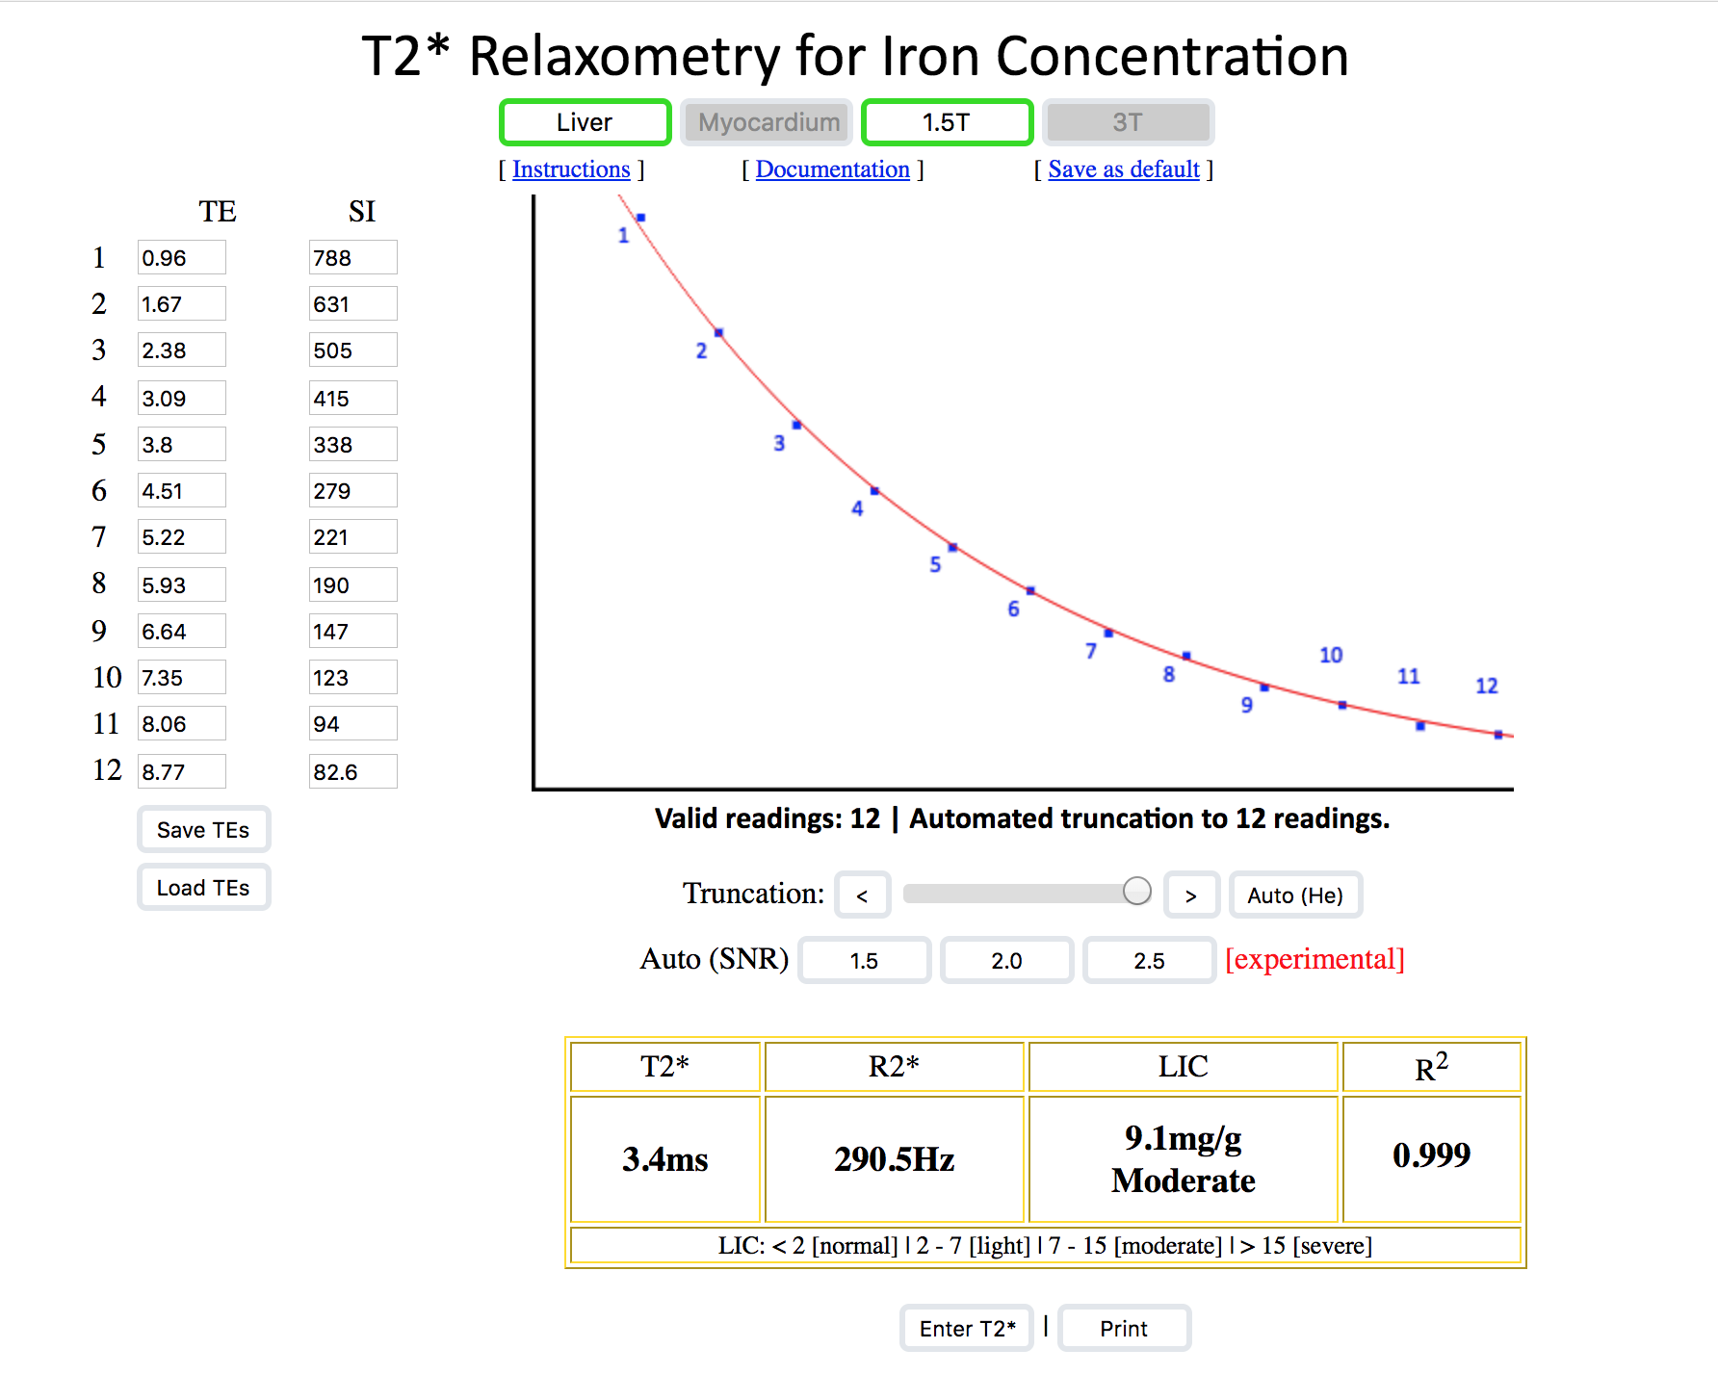 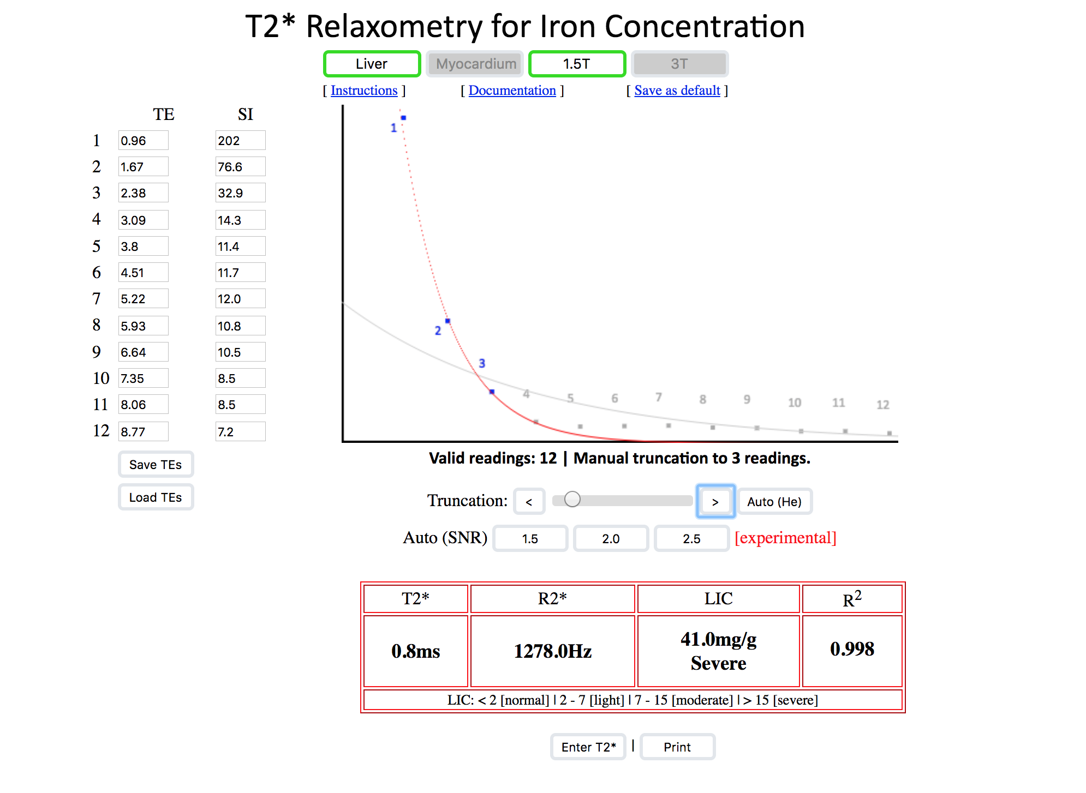

**Figure 6:** Sample screenshot of online T2* analysis tool. The user is responsible for typing in the correct echo time values in the leftmost column (red box) and the average signal intensity from the region of interest in the right hand columns (blue box). The left trace is from a patient with moderate iron load and all of the points are included in the fit. The right trace demonstrates a patient with severe iron load. It is critical to exclude all of the later echo times where the liver is completely black (in this case, all but three echoes). As shown, these echoes that contain only noise will lie above the best fit (red) line. It is critically important that the truncation optimize the fit on the first three echoes because these have the greatest weight on the R2* value.

|  |
| --- |
| *Screen shot 2016-01-10 at 3* |
| **Figure 7**: (Left) Representative region of interest calculated for pixelwise fitting. (Right) Corresponding R2* map. |

*Pixelwise calculation using an exponential + constant fit to signal decay:*Some investigative centers utilize software that calculates signal decay on a pixel by pixel basis, using a exponential plus constant description of signal decay4-6. Regions of interest typically encompass the entire liver profile, excluding the aorta and major hilar vessels (Figure 7, left). The software calculates R2* values over all the points in the region of interest (Figure 6, right) and calculates the mean or median R2* to approximate the whole liver value.

Using these types of analyses, a different calibration curve4should be used to convert R2* (or T2*) to LIC as follows:

LIC = 0.0254 * R2* + 0.2 or LIC = 25.4/T2* + 0.2 (Equation 2)

The pixelwise and region based analysis techniques yield different estimates of T2* and R2* for the same images. However, when proper calibration curve is paired with the analysis technique, LIC measurements are unbiased with one another 7.

**References**

1. Garbowski MW, Carpenter JP, Smith G, et al. Biopsy-based calibration of T2* magnetic resonance for estimation of liver iron concentration and comparison with R2 Ferriscan. *J Cardiovasc Magn Reson*. 2014;16:40.

2. Fernandes JL, Fioravante LAB, Verissimo MP, Loggetto SR. A free software for the calculation of T2* values for iron overload assessment. *Acta Radiol*. 2017;58(6):698-701.

3. Git KA, Fioravante LA, Fernandes JL. An online open-source tool for automated quantification of liver and myocardial iron concentrations by T2* magnetic resonance imaging. *Br J Radiol*. 2015;88(1053):20150269.

4. Wood JC, Enriquez C, Ghugre N, et al. MRI R2 and R2* mapping accurately estimates hepatic iron concentration in transfusion-dependent thalassemia and sickle cell disease patients. *Blood*. 2005;106(4):1460-1465.

5. Meloni A, Zmyewski H, Rienhoff HY, Jr., et al. Fast approximation to pixelwise relaxivity maps: validation in iron overloaded subjects. *Magn Reson Imaging*. 2013;31(7):1074-1080.

6. Positano V, Salani B, Pepe A, et al. Improved T2* assessment in liver iron overload by magnetic resonance imaging. *Magn Reson Imaging*. 2009;27(2):188-197.

7. Meloni A, Rienhoff HY, Jr., Jones A, Pepe A, Lombardi M, Wood JC. The use of appropriate calibration curves corrects for systematic differences in liver R2* values measured using different software packages. *Br J Haematol*. 2013;161(6):888-891.